**WEKA ASSIGNMENT**

**BY:**

**JEYABALA.B**

**1. DATASET DESCRIPTION:**

Dataset Name: Contact-lenses

Source of the dataset: <https://github.com/tertiarycourses/Weka/blob/master/Weka%20datasets/contact>-lenses.arff

Dataset description: The data set contains 1 classes of 24 instances each where each class refers to a class of contact-lenses dataset.

No of attributes: 5

No of instances: 24

**2. INPUT & OUTPUT:**

|  |  |  |
| --- | --- | --- |
| CONTACT-LENSES | 1. AGE 2. PRESCRIP 3. ASTIGATISM 4. TEAR PROD RATE 5. CONTACT LENSES 6. CLASS | AGE : CLASS  PRESCRIP : CLASS  ASTIGATISM : CLASS  TEAR PROD RATE : CLASS  CONTACT LENSES: CLASS |

**3. DATA PREPARATION:**

Removal of null data types, empty instances and false attribute.

**4. SELECTING AN ALGORITHM:**

|  |  |  |
| --- | --- | --- |
| **Algorithm** | **Result from Weka** | |
| **Correctly Classified Instances** | **Mean Absolute Error** |
| **Weka Classifiers** | | |
| NaiveBayes | 17 | 0.2306 |
| NaiveBayesMultinominalText | 15 | 0.3778 |
| NaiveBayesUpdateable | 17 | 0.2545 |
| **Weka Classifiers Functions** | | |
| Logistic | 16 | 0.2241 |
| MultilayerPerceptron | 17 | 0.2072 |
| **Weka Classifiers Meta** | | |
| AdaBoostM1 | 17 | 0.3581 |
| Bagging | 14 | 0.3068 |
| **Weka Classifier Trees** | | |
| J48 | 20 | 0.1552 |
| RandomTree | 17 | 0.2083 |
| **Weka Classifier Rules** | | |
| DecisionTable | 18 | 0.2979 |
| JRip | 18 | 0.2051 |

**5.DATA PREPROCESSING:**

|  |  |
| --- | --- |
| **Attribute Evaluator** | Classifier Subset Eval (Classifier: meta.Bagging with training parameter: classifiers = J48 and the others in their default) |
| **Search Method** | BestFirst (Direction: Forward) |
| **Evaluation Mode** | 10-fold cross-validation (Folds = 10, Seed =1) |

1. **TREE PRODUCED:**

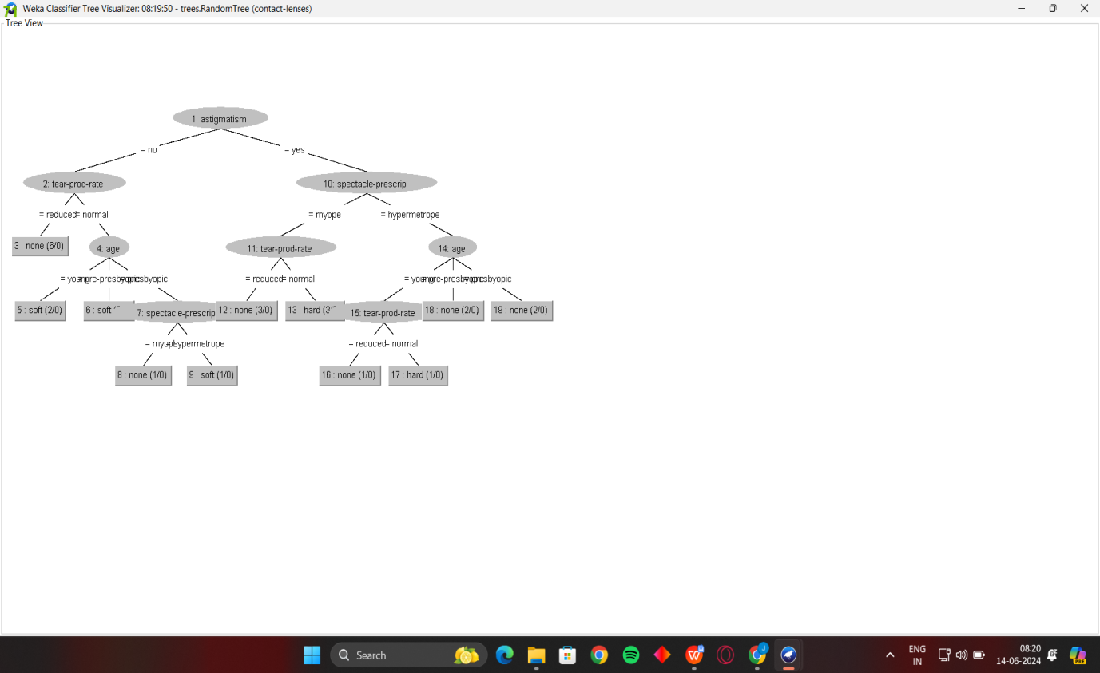

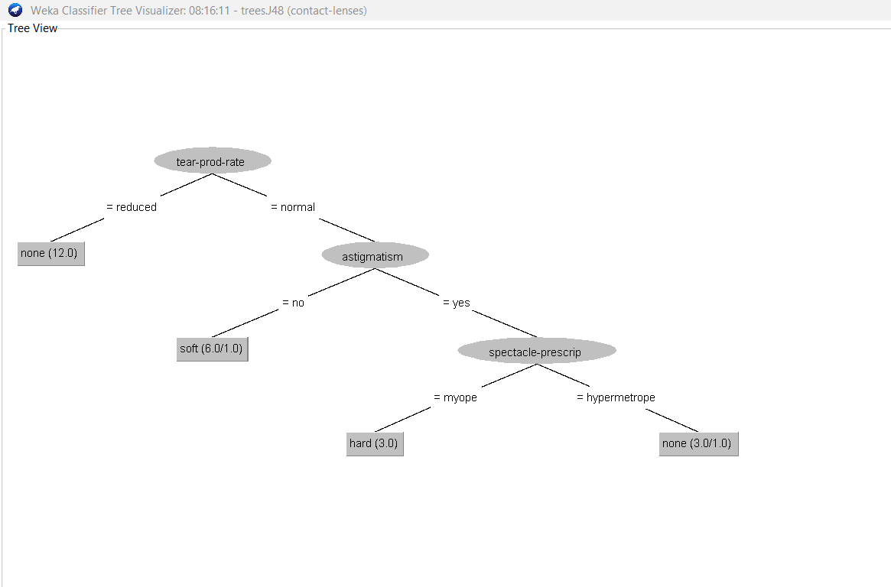

**7. SCREENSHOTS:**

